**Name**: Dan Marvin Cuartero **Year & Section**: BSIT 2B

Code:

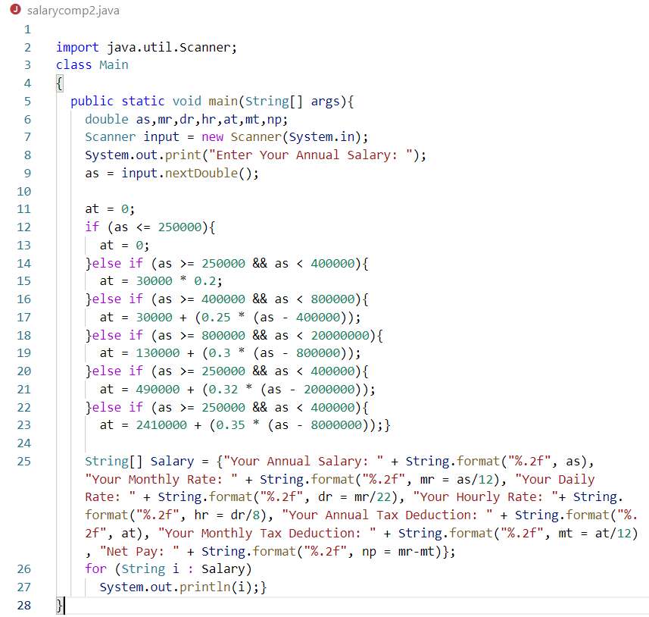

Output:

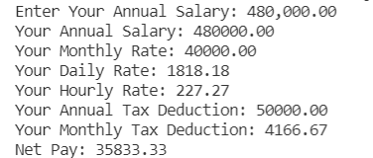

Link:

https://github.com/danmarvincuartero/test.git